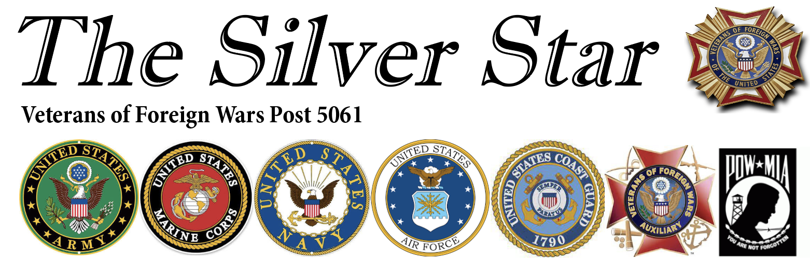
Commander’s Corner
Happy Summer! Thank you to everyone who volunteered for Memorial Weekend Poppies and the picnic. The Post depends on volunteers to keep things running, and your support truly makes a difference. Our poppy distribution at Bear Valley King Soopers brought in roughly $2,000 this year. While that’s down from $3,000 last year—and last year was also down from the year before—our recruiting efforts may help improve future results. I’d also like to thank the members who helped with the Day of Service. Four of us worked together to clean the parking lot across the street, and your efforts were greatly appreciated. The Memorial Day Picnic was a success, with about 75 people attending. Thank you for coming out and bringing something to share! The State Convention will be held June 25th–28th at Post 9644 and Post 5061. I will be attending this year, I look forward to seeing some of our Post members there. We will be holding a cleaning party at the Post on June 6th at 9 AM. We need as many people as possible, as we’ll be cleaning both inside and outside. Even an hour or two of your time would be a huge help—many hands make light work. And don’t forget—our next Picnic is on July 4th from 1–4 PM. Please bring a side dish. The Post will provide burgers and hot dogs. The Mr. E Band will play from 4-to7 PM right after the Picnic!
Best Regards
Craig Clark Commander 5061

JUNE 2026
Auxiliary News
It's really too bad! It's too bad we can't have our Post and Auxiliary members and visitors showing up volunteering to help distribute Buddy Poppies for Memorial Day. They showed up for the free picnic. It's also too bad that there were just a few of us that showed up for the Day of Service project of helping pick up trash, etc. across the street from the Post. They sure enjoy having that free parking handy when we have a large crowd, and it's free. Actually quite a few used it when they came for the free picnic! It's not like we ask for your help all the time, but when we do for special projects, it too bad we can't have better participation. The State Convention will be held toward the last part of June at Post 9644 if you have any interest in attending that.
Well, I guess I'm done lecturing as this will be my last newsletter as your Auxiliary President. We've had our elections, etc., and I'll be handing the gavel to Shiela Medina, your next President. I know she will be a wonderful President as she takes over after convention. Let's support her all we can.
In my 40 years as a VFW Auxiliary member, I've attended lots of meetings and conventions, and seen a lot of changes. I have been Aux President four times, (two at Aux.#2461 and two at #5061). For the most part, I've really enjoyed being your president.
Through my participation in so many events, I've met some of the most kindest and most wonderful people I had ever hoped to meet and become friends with. And for that, I am so very grateful to have had this experience. You'll be seeing me around as I continue to support our Post and Auxiliary however I can, with health permitting.
I hope you have a great summer, and a safe and healthy summer. I look forward to seeing you soon.

Warmest Regards,
Sharon Ervin, VFW Auxiliary #5061 President

Post Members: Did you pay your dues? Check your membership card for your
anniversary date.

Auxiliary Members: Membership dues are due by December, 31, 2024.

Post Officers
Post Commander: Craig Clark
Sr. Vice Commander: Bruce Gibson
Jr. Vice Commander: Tammy Greene
Quartermaster: James Kruse
Adjutant: James Kruse
Chaplain: Manuel Sais
Judge Advocate: Vince Miller
Surgeon: Jim Kruse
Service Officer: Gary Williamson
Trustees: Gary Williamson, Jerry Jones, Blake Anderson
Home Board: Vince Miller, Joe Gomez, Frank Martinez, Jim Kruse, Harvey Nakayama
Bingo Manager: Jim Kruse
Canteen Appointees
Canteen Personnel Management:
Canteen Logistics Manager: Betty Medina
Hall Manager: Joe Tafoya
Kitchen Manager: Vince Miller

Auxiliary Officers
President: Sharon Ervin
Sr. Vice: Shila Medina
Jr. Vice: Bernadette Sannino
Treasurer: Janet Farris
Secretary: Kim Williamson
Chaplain: Janet Nelson
Conductor: Kathleen Hayes
Trustees: Ruth Gulden, Charlotte Lattin, Shiela Medina
Guard: Sedona Decint



